HW2 Askiseis Moodle Hlektrologia 19/10/1024 ΚΑΡΥΟΣ ΓΙΩΡΓΟΣ (30738)
Ask 1.70 Karyos G.
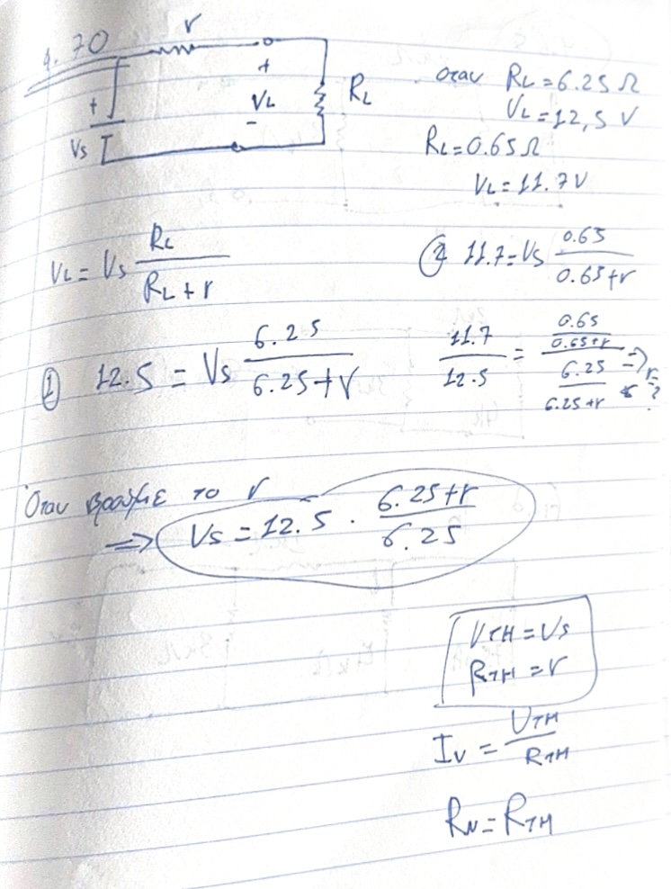

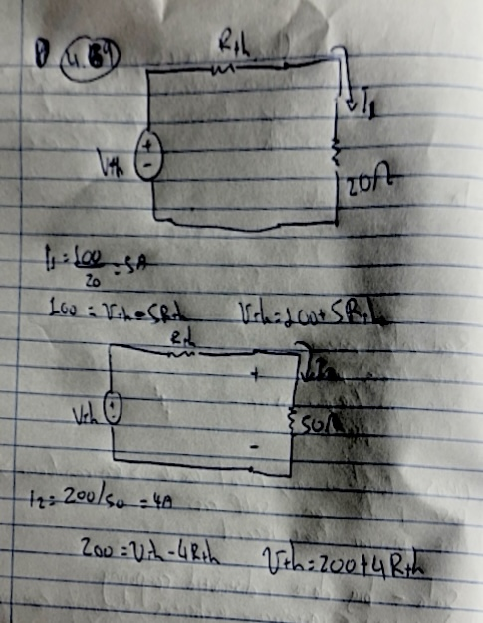

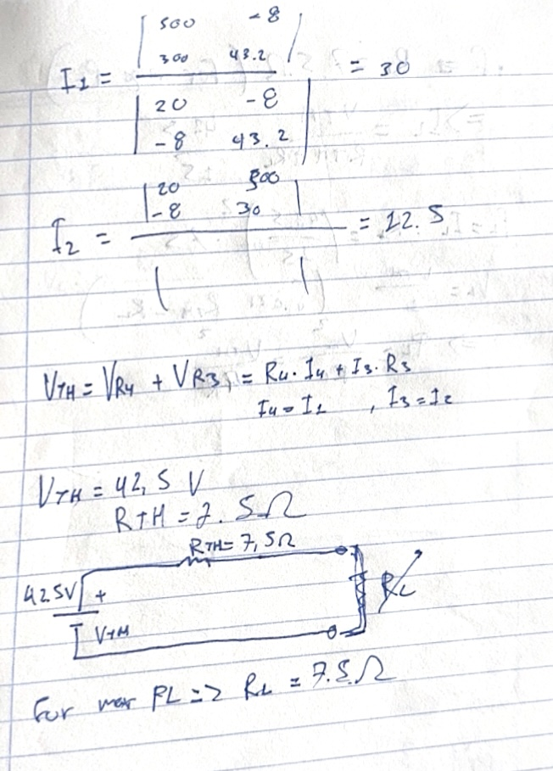

ask 4. 64 karyos Gergios
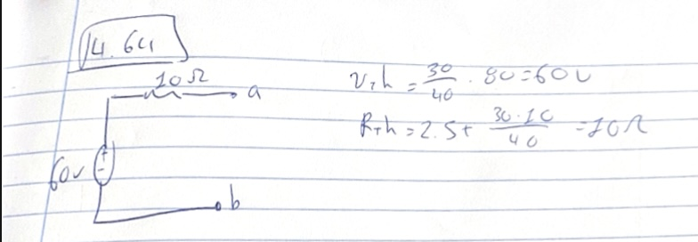

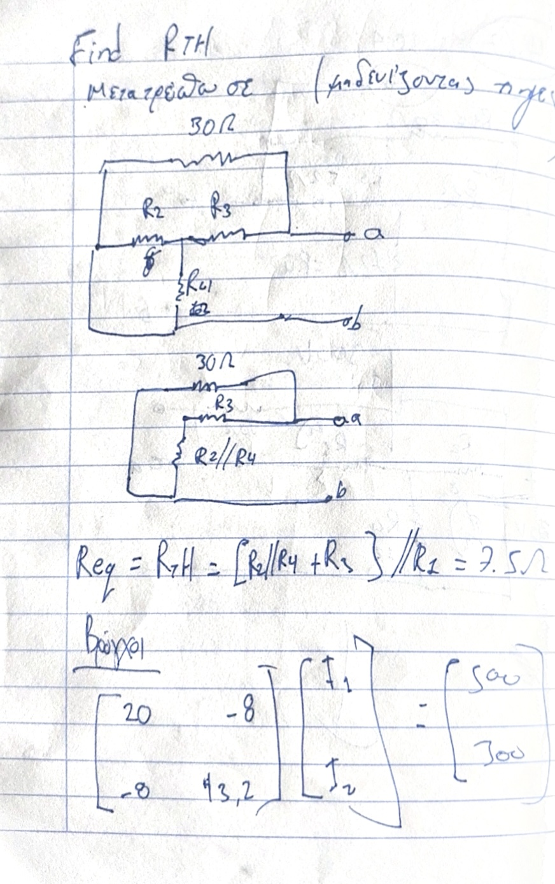

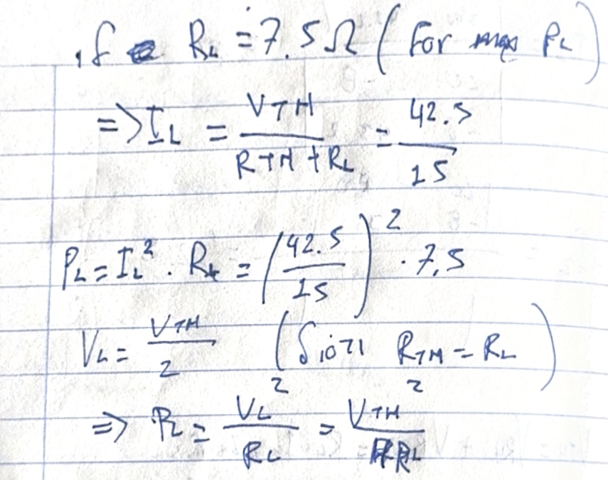

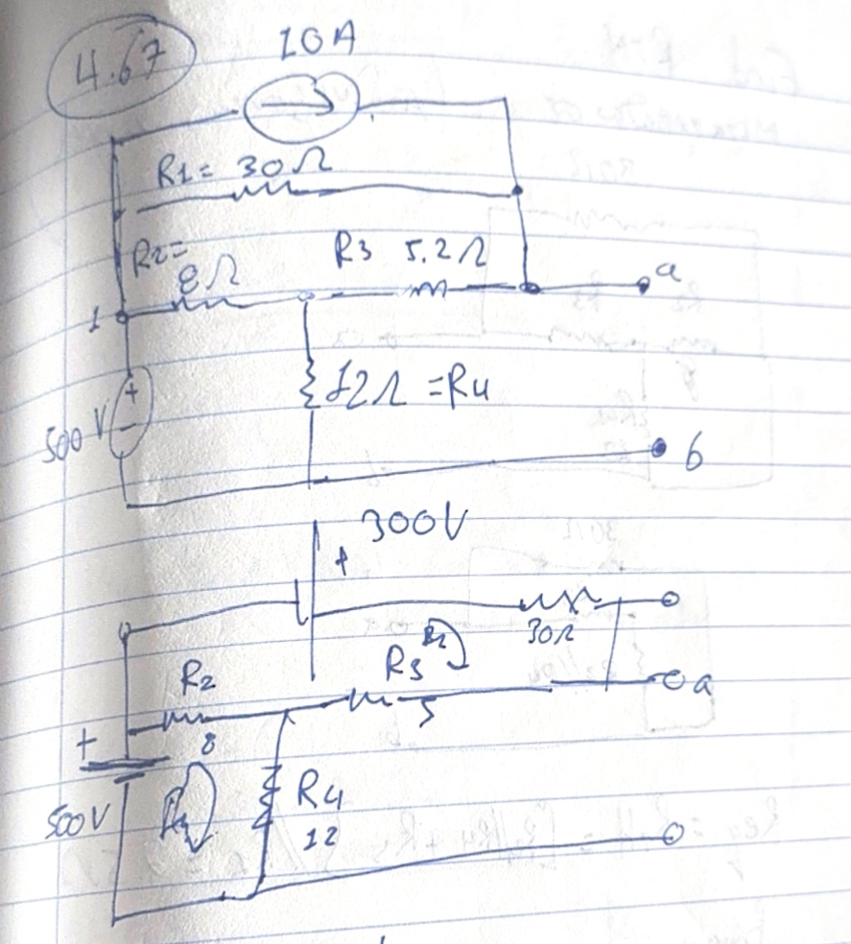
ASK 4.67
Karyos
Georgios

